AI Project Document
Aim: To create the maze game.
Algorithm:
Depth-First Search (DFS):
DFS is a recursive algorithm used for traversing or searching tree or graph data structures. It explores as far as possible along each branch before backtracking.
How It Works:
  - Start from a random cell, mark it as visited.
  - Randomly select a neighboring unvisited cell, remove the wall between the current cell and the chosen cell, and move to that cell.
  - Repeat until all cells are visited.
Advantages:
  - Simple to implement.
  - Produces a perfect maze (no loops).

Program:
import pygame
import pygame.math as math
import csv

# Constants
BASE_IMG_PATH = 'Assets/'
WIDTH, HEIGHT = 660, 660
FPS = 60
CHARACTER_SPEED = 4
TILE_SIZE = 12
FONT_SIZE = 36
TEXT_COLOR = (0, 0, 0)
LINE_SPACING = 5

class Utils:
@staticmethod
def load_image(filename):
return pygame.image.load(BASE_IMG_PATH + filename)

class Button:
def __init__(self, text, font, color, x, y, width, height):
self.font = font
self.color = color
self.rect = pygame.Rect(x, y, width, height)
self.text = text
self._update_surface()

def _update_surface(self):
self.surface = self.font.render(self.text, True, self.color)
self.text_rect = self.surface.get_rect(center=self.rect.center)

def draw(self, screen):
pygame.draw.rect(screen, (200, 200, 200), self.rect) # Button background
screen.blit(self.surface, self.text_rect) # Button text

def is_clicked(self, mouse_pos):
return self.rect.collidepoint(mouse_pos)

class MazeGame:
def __init__(self):
pygame.init()
self.screen = pygame.display.set_mode((WIDTH, HEIGHT), pygame.RESIZABLE)
self.clock = pygame.time.Clock()
self.running = True
self.reset_flags()

# Load and scale images
self.load_assets()

# Initialize player and map
self.initialize_player()
self.initialize_map()

# Initialize message display and restart button
self.font = pygame.font.SysFont(None, FONT_SIZE)
self.restart_button = Button("Restart", self.font, (0, 0, 0), WIDTH // 2 - 50, HEIGHT // 2 + 50, 90, 40)

def load_assets(self):
self.assets = {
'player': Utils.load_image('Box.png'),
'wall': Utils.load_image('wall.jpg'),
'grass': Utils.load_image('grass.jpg'),
'ground': Utils.load_image('ground.png'),
'finish': Utils.load_image('finish.png')
}
self.player_image = pygame.transform.scale(self.assets['player'], (TILE_SIZE, TILE_SIZE))
self.wall_image = pygame.transform.scale(self.assets['wall'], (TILE_SIZE, TILE_SIZE))
self.grass_image = pygame.transform.scale(self.assets['grass'], (TILE_SIZE, TILE_SIZE))
self.ground_image = pygame.transform.scale(self.assets['ground'], (TILE_SIZE, TILE_SIZE))
self.finish_image = pygame.transform.scale(self.assets['finish'], (TILE_SIZE, TILE_SIZE))

def get_wall_rects(self):
return [pygame.Rect(x * TILE_SIZE, y * TILE_SIZE, TILE_SIZE, TILE_SIZE)
for y, row in enumerate(self.map_creation)
for x, tile in enumerate(row)
if tile == 0]

def load_map_from_csv(self, filename):
with open(filename, newline='') as csvfile:
reader = csv.reader(csvfile)
return [[int(tile) for tile in row] for row in reader]

def draw_map(self):
for y, row in enumerate(self.map_creation):
for x, tile in enumerate(row):
if tile == 0:
self.screen.blit(self.wall_image, (x * TILE_SIZE, y * TILE_SIZE))
if tile == 1:
self.screen.blit(self.grass_image, (x * TILE_SIZE, y * TILE_SIZE))
if tile == 2:
if self.is_eligible:
if self.exit_clue == [True, True, True]:
self.screen.blit(self.finish_image, (x * TILE_SIZE, y * TILE_SIZE))
else:
self.screen.blit(self.grass_image, (x * TILE_SIZE, y * TILE_SIZE))
else:
self.screen.blit(self.grass_image, (x * TILE_SIZE, y * TILE_SIZE))
if tile == 3:
if self.is_eligible:
self.screen.blit(self.ground_image, (x * TILE_SIZE, y * TILE_SIZE))
else:
self.screen.blit(self.grass_image, (x * TILE_SIZE, y * TILE_SIZE))

self.display_messages()

def display_messages(self):
if self.reach_center:
self.show_msg("You've reached the center area!\nNow find the true exit!")
if self.is_trapped:
self.show_msg("You're trapped. Restart the game!")
self.button_visible = True
self.restart_button.draw(self.screen)
if self.instantDeath:
self.show_msg("You stepped on something you shouldn't have.\nRestart the game!")
self.button_visible = True
self.restart_button.draw(self.screen)
if self.noEntry:
self.show_msg("You are not eligible to enter")
if self.game_over:
self.show_msg("Congratulation!\nNew Game")
self.button_visible = True
self.restart_button.draw(self.screen)

def update_map(self, start_x, start_y, end_x, end_y, new_value):
for y in range(start_y, end_y + 1):
for x in range(start_x, end_x + 1):
if 0 <= y < len(self.map_creation) and 0 <= x < len(self.map_creation[y]):
self.map_creation[y][x] = new_value
self.wall_rects = self.get_wall_rects()

def movement_controller(self):
if self.is_trapped or self.instantDeath or self.game_over:
return

keys = pygame.key.get_pressed()
direction = math.Vector2(
(keys[pygame.K_RIGHT] - keys[pygame.K_LEFT]),
(keys[pygame.K_DOWN] - keys[pygame.K_UP])
)

if direction.length() > 0:
direction.normalize_ip()

movement = direction * CHARACTER_SPEED
new_player_rect = self.player_rect.move(movement.x, movement.y)

if not any(new_player_rect.colliderect(wall_rect) for wall_rect in self.wall_rects):
self.player_rect.move_ip(movement.x, movement.y)

self.player_rect.x = max(0, min(self.player_rect.x, WIDTH - self.player_rect.width))
self.player_rect.y = max(0, min(self.player_rect.y, HEIGHT - self.player_rect.height))

self.map_logic()

def map_logic(self):
tile_x = self.player_rect.x // TILE_SIZE
tile_y = self.player_rect.y // TILE_SIZE

rects = {
'fullMap': pygame.Rect(1 * TILE_SIZE, 1 * TILE_SIZE, (53 - 1 + 1) * TILE_SIZE, (51 - 1 + 1) * TILE_SIZE),
'trueExit': pygame.Rect(1 * TILE_SIZE, 15 * TILE_SIZE, (3 - 1 + 1) * TILE_SIZE, (20 - 15 + 1) * TILE_SIZE),
'centerRectWall1': pygame.Rect(30 * TILE_SIZE, 18 * TILE_SIZE, (33 - 30 + 1) * TILE_SIZE, (21 - 18 + 1) * TILE_SIZE),
'centerRectWall2': pygame.Rect(28 * TILE_SIZE, 16 * TILE_SIZE, (35 - 28 + 1) * TILE_SIZE, (22 - 16 + 1) * TILE_SIZE),
'upperTunnelWall': pygame.Rect(30 * TILE_SIZE, 10 * TILE_SIZE, (32 - 30 + 1) * TILE_SIZE, (14 - 10 + 1) * TILE_SIZE),
'bottomTunnelWall': pygame.Rect(31 * TILE_SIZE, 25 * TILE_SIZE, (32 - 31 + 1) * TILE_SIZE, (28 - 25 + 1) * TILE_SIZE),
'leftTunnelWall': pygame.Rect(21 * TILE_SIZE, 19 * TILE_SIZE, (26 - 21 + 1) * TILE_SIZE, (20 - 19 + 1) * TILE_SIZE),
'leftUpperRectWall': pygame.Rect(19 * TILE_SIZE, 10 * TILE_SIZE, (26 - 19 + 1) * TILE_SIZE, (18 - 10 + 1) * TILE_SIZE),
'rightUpperRectWall' : pygame.Rect(37 * TILE_SIZE, 16 * TILE_SIZE, (42 - 37 + 1) * TILE_SIZE, (18 - 16 + 1) * TILE_SIZE),
'rightBottomRectWall': pygame.Rect(37 * TILE_SIZE, 21 * TILE_SIZE, (43 - 37 + 1) * TILE_SIZE, (24 - 21 + 1) * TILE_SIZE),
'bottomTrapWall': pygame.Rect(25 * TILE_SIZE, 49 * TILE_SIZE, (30 - 25 + 1) * TILE_SIZE, (51 - 49 + 1) * TILE_SIZE),
'rightMostWall': pygame.Rect(46 * TILE_SIZE, 32 * TILE_SIZE, (49 - 46 + 1) * TILE_SIZE, (38 - 32 + 1) * TILE_SIZE),
'rightUpperWall': pygame.Rect(49 * TILE_SIZE, 6 * TILE_SIZE, (53 - 49 + 1) * TILE_SIZE, (8 - 6 + 1) * TILE_SIZE),
'middleUpperWall': pygame.Rect(20 * TILE_SIZE, 1 * TILE_SIZE, (24 - 20 + 1) * TILE_SIZE, (6 - 1 + 1) * TILE_SIZE),
'centerUpperWall': pygame.Rect(30 * TILE_SIZE, 7 * TILE_SIZE, (33 - 30 + 1) * TILE_SIZE, (10 - 7 + 1) * TILE_SIZE),
'leftCenterWall': pygame.Rect(16 * TILE_SIZE, 25 * TILE_SIZE, (18 - 16 + 1) * TILE_SIZE, (27 - 25 + 1) * TILE_SIZE),
'instantDeath': pygame.Rect(34 * TILE_SIZE, 34 * TILE_SIZE, (37 - 34 + 1) * TILE_SIZE, (35 - 34 + 1) * TILE_SIZE),
'rightOfUpperRectWall': pygame.Rect(43 * TILE_SIZE, 10 * TILE_SIZE, (46 - 43 + 1) * TILE_SIZE, (16 - 10 + 1) * TILE_SIZE),
'centerBottomWall' : pygame.Rect(28 * TILE_SIZE, 40 * TILE_SIZE, (31 - 28 + 1) * TILE_SIZE, (42 - 40 + 1) * TILE_SIZE),
'exitClueEntry1' : pygame.Rect(15 * TILE_SIZE, 31 * TILE_SIZE, (17 - 15 + 1) * TILE_SIZE, (31 - 31 + 1) * TILE_SIZE),
'exitClueExit1' : pygame.Rect(9 * TILE_SIZE, 28 * TILE_SIZE, (14 - 9 + 1) * TILE_SIZE, (31 - 28 + 1) * TILE_SIZE),
'leftBottomWall' : pygame.Rect(1 * TILE_SIZE, 47 * TILE_SIZE, (4 - 1 + 1) * TILE_SIZE, (48 - 47 + 1) * TILE_SIZE),
'exitClueEntry2' : pygame.Rect(13 * TILE_SIZE, 46 * TILE_SIZE, (15 - 13 + 1) * TILE_SIZE, (47 - 46 + 1) * TILE_SIZE),
'exitClueExit2' : pygame.Rect(19 * TILE_SIZE, 50 * TILE_SIZE, (20 - 19 + 1) * TILE_SIZE, (52 - 50 + 1) * TILE_SIZE),
}

if rects['fullMap'].colliderect(self.player_rect):
self.update_map(10, 53, 12, 53, 0)
self.update_map(28, 53, 30, 53, 0)
self.update_map(42, 53, 44, 53, 0)
self.update_map(51, 53, 52, 53, 0)

if rects['trueExit'].colliderect(self.player_rect):
if not self.is_eligible:
self.update_map(3, 15, 3, 20, 0)
self.noEntry = True
elif self.is_eligible:
if self.exit_clue != [True, True, True]:
self.update_map(3, 15, 3, 20, 0)
self.noEntry = True
else:
self.game_over = True

else:
if self.is_eligible:
self.update_map(3, 15, 3, 20, 2)
self.noEntry = False
else:
self.update_map(3, 15, 3, 20, 1)
self.noEntry = False

self.reach_center = rects['centerRectWall1'].colliderect(self.player_rect)

if rects['centerRectWall2'].colliderect(self.player_rect):
self.update_map(27, 19, 27, 20, 0)
self.update_map(31, 24, 32, 24, 0)
self.is_eligible = True
else:
self.update_map(27, 19, 27, 20, 1)
self.update_map(31, 24, 32, 24, 1)

if rects['upperTunnelWall'].colliderect(self.player_rect):
self.update_map(30, 10, 30, 14, 1)
else:
self.update_map(30, 10, 30, 14, 0)

if rects['bottomTunnelWall'].colliderect(self.player_rect):
self.update_map(31, 30, 32, 30, 0)
self.update_map(31, 24, 32, 24, 0)
self.is_trapped = True

if rects['leftTunnelWall'].colliderect(self.player_rect):
self.update_map(19, 19, 19, 20, 0)
self.update_map(27, 19, 27, 20, 0)
self.is_trapped = True

if rects['leftUpperRectWall'].colliderect(self.player_rect):
self.update_map(19, 10, 19, 11, 0)
self.update_map(20, 18, 26, 18, 1)
else:
self.update_map(19, 10, 19, 11, 1)
self.update_map(20, 18, 26, 18, 0)

if rects['rightUpperRectWall'].colliderect(self.player_rect):
self.update_map(37, 18, 42, 18, 1)
else:
self.update_map(37, 18, 42, 18, 0)

if rects['rightBottomRectWall'].colliderect(self.player_rect):
self.update_map(37, 21, 42, 21, 1)
else:
self.update_map(37, 21, 42, 21, 0)

if rects['bottomTrapWall'].colliderect(self.player_rect):
self.update_map(25, 47, 27, 47, 0)
self.update_map(28, 53, 30, 53, 0)
self.is_trapped = True

if rects['rightMostWall'].colliderect(self.player_rect):
self.update_map(46, 33, 46, 36, 0)
else:
self.update_map(46, 33, 46, 36, 1)

if rects['rightUpperWall'].colliderect(self.player_rect):
self.update_map(50, 6, 52, 6, 1)
self.update_map(49, 7, 49, 8, 0)
else:
self.update_map(50, 6, 52, 6, 0)
self.update_map(49, 7, 49, 8, 1)

if rects['middleUpperWall'].colliderect(self.player_rect):
self.update_map(21, 6, 24, 6, 1)
else:
self.update_map(21, 6, 24, 6, 0)

if rects['centerUpperWall'].colliderect(self.player_rect):
self.update_map(31, 9, 32, 9, 0)
else:
self.update_map(31, 9, 32, 9, 1)

if rects['leftCenterWall'].colliderect(self.player_rect):
self.update_map(16, 27, 18, 27, 1)
else:
self.update_map(16, 27, 18, 27, 0)

if rects['instantDeath'].colliderect(self.player_rect):
if not self.is_eligible:
self.instantDeath = True
elif self.is_eligible:
self.exit_clue[2] = True
self.instantDeath = False

if rects['rightOfUpperRectWall'].colliderect(self.player_rect):
self.update_map(43, 11, 43, 15, 1)
else:
self.update_map(43, 11, 43, 15, 0)

if rects['centerBottomWall'].colliderect(self.player_rect):
self.update_map(31, 40, 31, 41, 0)
else:
self.update_map(31, 40, 31, 41, 1)

if rects['exitClueEntry1'].colliderect(self.player_rect):
if self.is_eligible:
self.update_map(15, 30, 15, 31, 1)
else:
self.update_map(15, 30, 15, 31, 0)

if rects['exitClueExit1'].colliderect(self.player_rect):
self.update_map(9, 30, 9, 31, 1)
self.exit_clue[0] = True
else:
self.update_map(9, 30, 9, 31, 0)

if rects['leftBottomWall'].colliderect(self.player_rect):
self.update_map(1, 48, 4, 48, 1)
else:
self.update_map(1, 48, 4, 48, 0)

if rects['exitClueEntry2'].colliderect(self.player_rect):
if self.is_eligible:
self.update_map(13, 47, 15, 47, 1)
self.update_map(13, 48, 13, 48, 1)
else:
self.update_map(13, 47, 15, 47, 0)
self.update_map(13, 48, 13, 48, 0)

if rects['exitClueExit2'].colliderect(self.player_rect):
self.update_map(20, 50, 20, 52, 1)
self.exit_clue[1] = True
else:
self.update_map(20, 50, 20, 52, 0)

def initialize_player(self):
self.player_rect = self.player_image.get_rect(centerx=200, centery=HEIGHT)

def initialize_map(self):
self.map_layout = self.load_map_from_csv(BASE_IMG_PATH + 'FinalMazeMap.csv')
self.map_creation = [row[:] for row in self.map_layout]
self.wall_rects = self.get_wall_rects()

def reset_flags(self):
self.is_trapped = False
self.reach_center = False
self.instantDeath = False
self.is_eligible = False
self.noEntry = False
self.exit_clue = [False, False, False]
self.game_over = False
self.button_visible = False

def restart_game(self):
self.initialize_player()
self.initialize_map()
self.reset_flags()

def show_msg(self, text):
lines = text.split('\n')
y_offset = HEIGHT // 2 - (len(lines) * FONT_SIZE + (len(lines) - 1) * LINE_SPACING) // 2
for line in lines:
message_surface = self.font.render(line, True, TEXT_COLOR)
message_rect = message_surface.get_rect(center=(WIDTH // 2, y_offset))
self.screen.blit(message_surface, message_rect)
y_offset += FONT_SIZE + LINE_SPACING

def game(self):
while self.running:
for event in pygame.event.get():
if event.type == pygame.QUIT:
self.running = False
elif event.type == pygame.MOUSEBUTTONDOWN and self.restart_button.is_clicked(event.pos):
if self.button_visible:
self.restart_game()

self.movement_controller()
self.screen.fill((255, 255, 255))
self.draw_map()
self.screen.blit(self.player_image, self.player_rect.topleft)
pygame.display.flip()
self.clock.tick(FPS)

pygame.quit()

if __name__ == "__main__":
MazeGame().game()

Output:
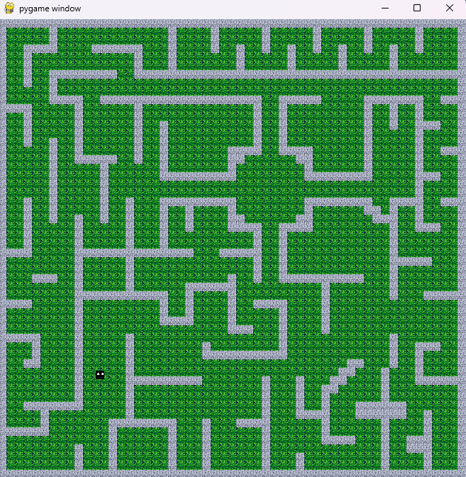
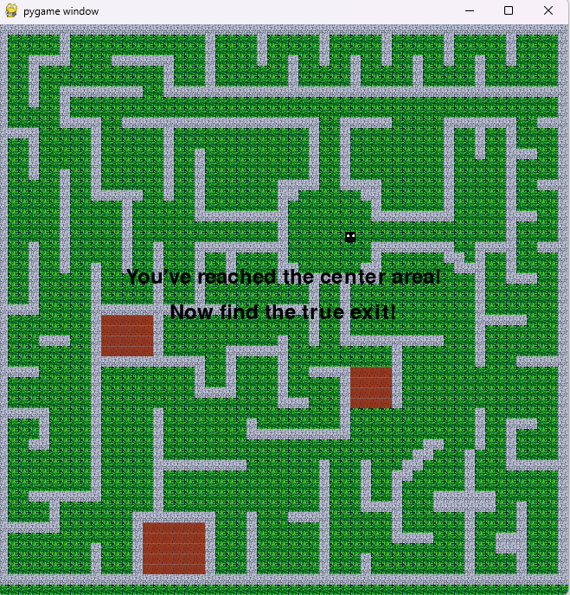

Conclusion: The progame to create the maze game has been executed successfully.

